Thank you for assisting us with the patient movement process.

- Movement requirements listed below are mandatory.
- All steps must be completed before we can gain final approval by our Flight Surgeon.
- For any further guidance; phone numbers and organizational email boxes are listed at the end of this document.

**Please complete for patient and any individuals traveling with patient

COVID-19 SCREEN | Yes | No
Any current signs/symptoms of Covid-19 or viral type illness? i.e. cough, fatigue, fever
Current Covid-19 test results?
History of positive infection of Covid-19?
Any quarantine for Covid-19 in past 30 days?
Documentation of recovery within past 30 days?
Documentation of immunization completed? List date completed below
Is the individual familiar with how to self-monitor and what actions to take if he/she develops COVID-19 symptoms or contracts COVID-19?

Please explain any “Yes” answers below:
__________________________________________________________________________________________________________________________________________________________________________________________________________________________________________

Initial Task Description
 |  | Eligibility & Accepting Provider | All patients must meet eligibility requirements and have confirmation of an accepting provider at the destination facility
 |  | Contact numbers | Please include contact numbers and/or email information for provider, case manager, and current inpatient unit
 | 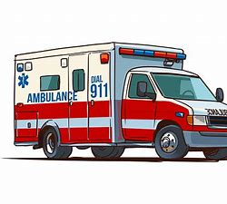 | Tricare or DHA Authorizations | Tricare and/or DHA Authorizations are required for both inpatient care and ground transportation at patient’s origin and destination  **Note: Exceptions include complimentary EMS services at your location and/or military locations with EMS capability
 | 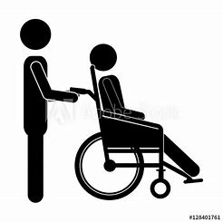 | Non-medical attendant (NMA) | Please provide name, DOB, and weight of any NMA who will be moving with patient (final approval by TPMRC-A Flight Surgeon)
 | 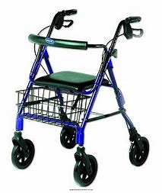 | Additional Medical equipment | Any medical equipment to accompany patient, such as; personal wheelchair, pulmonary vest, walker. All items require written specifications to include dimensions (height, width) and weight of item(s)
 |  | Discharge orders or AF 3899 | Provider discharge orders or a Trac2es AF3899 (MIL form) which includes the signature/date of provider who is authorizing patient movement & MD orders. Please fax or email to org box listed below

Initial Task Description
 |  | Medications | Medication supply for 2-3 days, and medical records should accompany patient to aircraft
 |  | Anti-Hijacking or Flight Safety | All patients, NMAs, luggage and carry-ons will be anti-hijacked to prevent the onload of weapons, explosives, lighters, matches, sharps or any other item which could be a potential threat to personnel and/or aircraft. *For reference please review AFI 48-307 v1
 |  | Luggage | Allowance of one suitcase and one carry-on (i.e. purse, backpack) for patient and each NMA. Limit of 30 pounds for each suitcase
 |  | Apparel | For all patients and NMAs, please ensure proper apparel for flight. Closed-toe shoes required for safety. High heels, flip-flops or platform shoes prohibited. Sweater or jacket recommended **Please verify with TPMRC-A for Mental Health patient requirements
 |  | Flight | Once the patient is assigned a date/time and airfield for the flight we will call the official POC approximately 24 hours prior and one-hour prior to aircraft arrival on the day of mission.

CHECKLIST COMPLETED BY/DATE:
______________________________________________________________________________
______________________________________________________________________________
PHONE NUMBERS
Medical Administration: 618-229-1420 Nurse desk: 618-229-3418
General questions about flight: 618-229-4200 24-hour contact: 618-229-4200
FAX & EMAIL
FAX number: 618-256-8728
Org box: transcom.scott.tcsg.mbx.gpmrc-pmcc@mail.mil
**Note: email org box does not accept encrypted email

